How to Pay the JMMUN Participation Fee

We would like you to pay the JMMUN conference fee pay by bank transfer if you are participating from inside Japan. (We give our thanks in advance for the extra time and the extra transfer fee that will be required with this method.)
We will send a confirmation email to the email address listed on your application form and inform you of our bank account. We ask that a coach or representative teacher from each school participating in the conference collect all fees from students and send them in one payment before the deadline.

Participating from Outside Japan
We recommend schools participating from abroad use TransferWise to pay the participation fee. This service offers transfer fees that are cheaper than those offered by most banks. (We give our thanks in advance for the extra time and the extra transfer fee that will be required with this method.)

You can get an estimate for your school’s payment using this site.

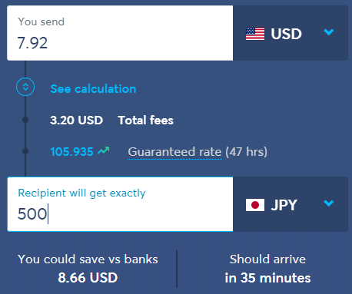

How to Send Money （Courtesy of TransferWise’s homepage）
